Click on link to the WC+ site: https://www.wellconnectplus.com/?company=1NCM40

New Users - *Cigna Members
  - Enter First Name, Last Name, DOB, and SSN
  - Select “Continue”
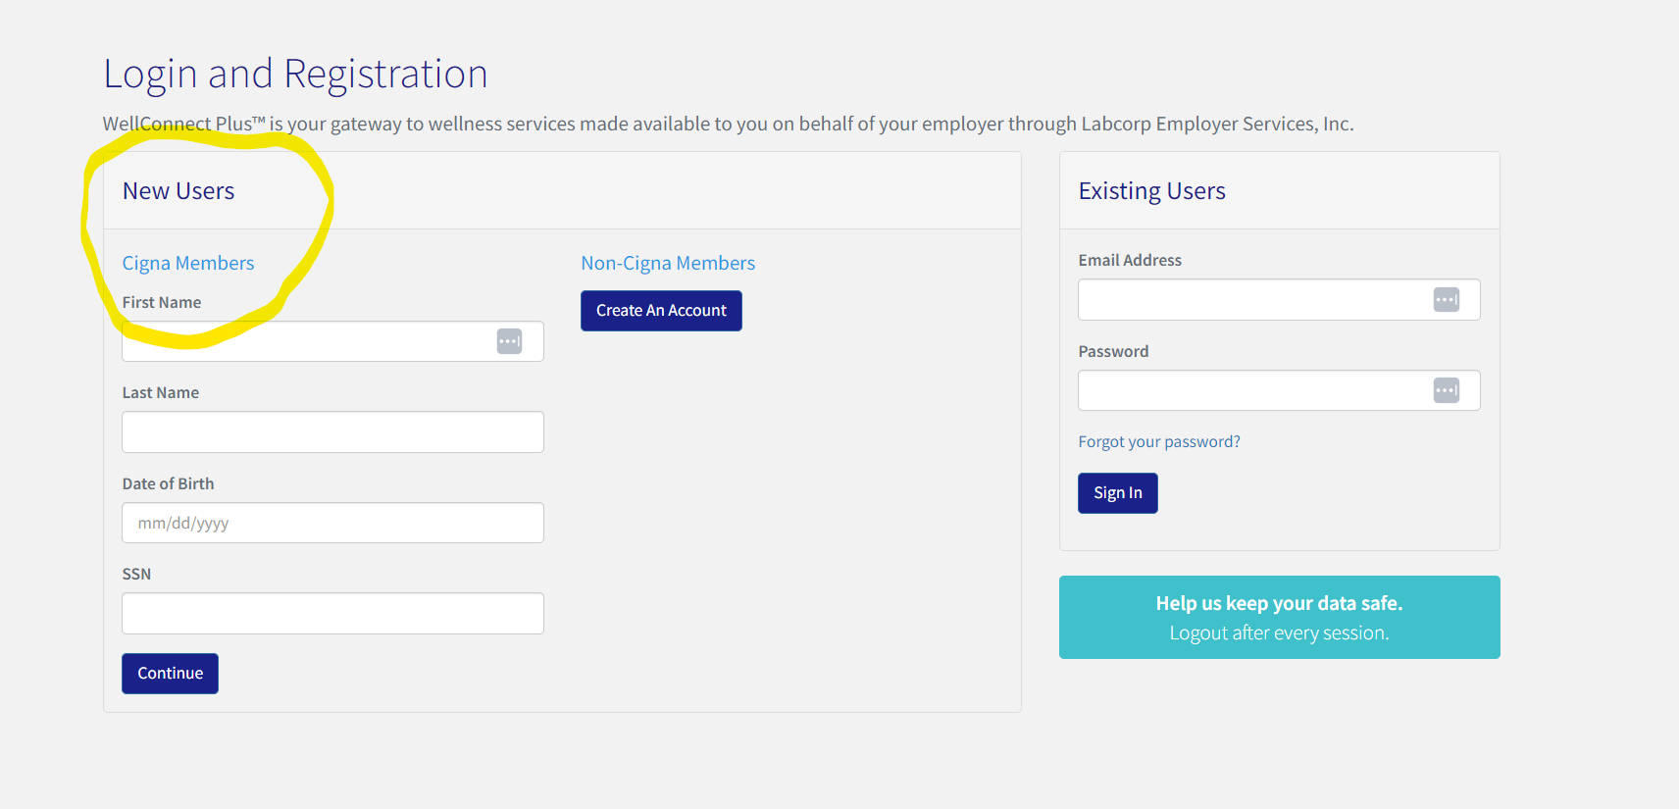
*If you are not insured through Cigna please scroll down for alternate registration instructions

Complete Registration
- Select your State
- Enter your email address
- Create a password
- Agree to the Terms of Use and Privacy Policy
- Select “Register”
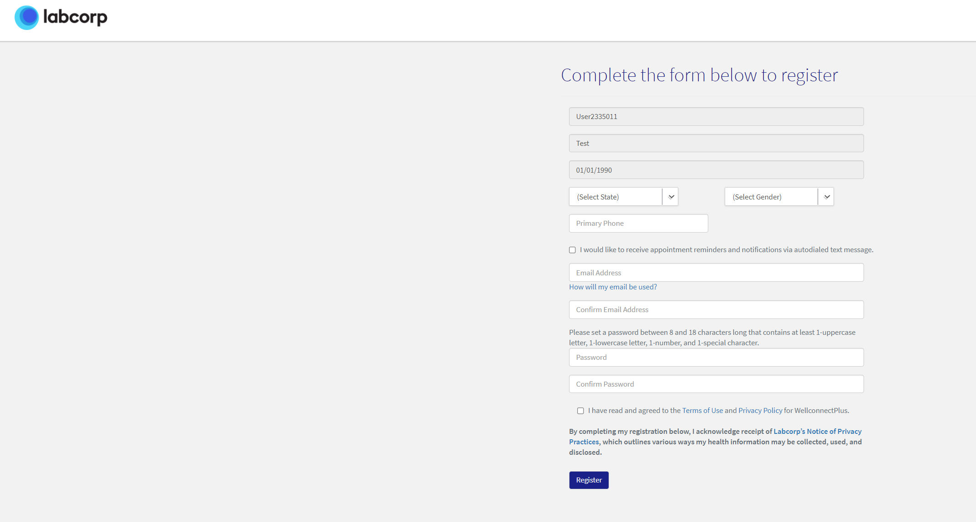

New Users – Non-Cigna Members
  - Under Non-Cigna Member, click Create An Account
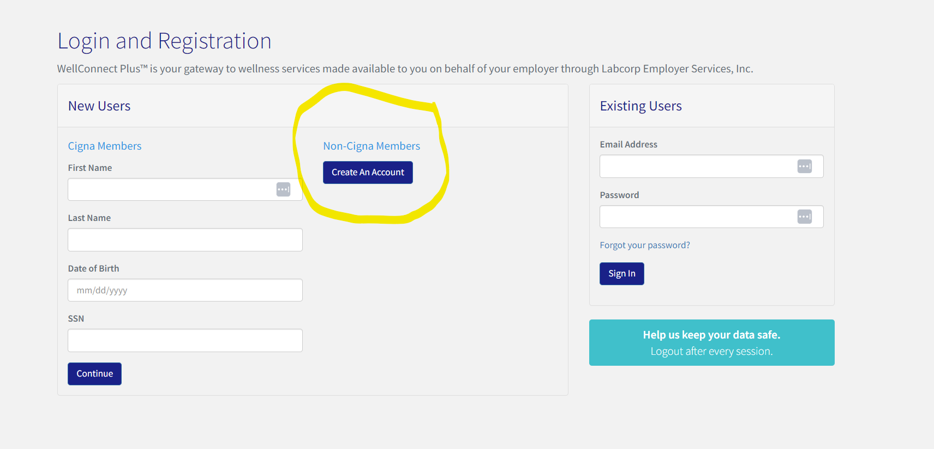

Complete Registration
- Access Code – “Mosaic2023”
- First & Last name
- Date of Birth
- Select your State
- Select Gender
- Enter your email address
- Create a password
- Agree to the Terms of Use and Privacy Policy
- Select “Register”

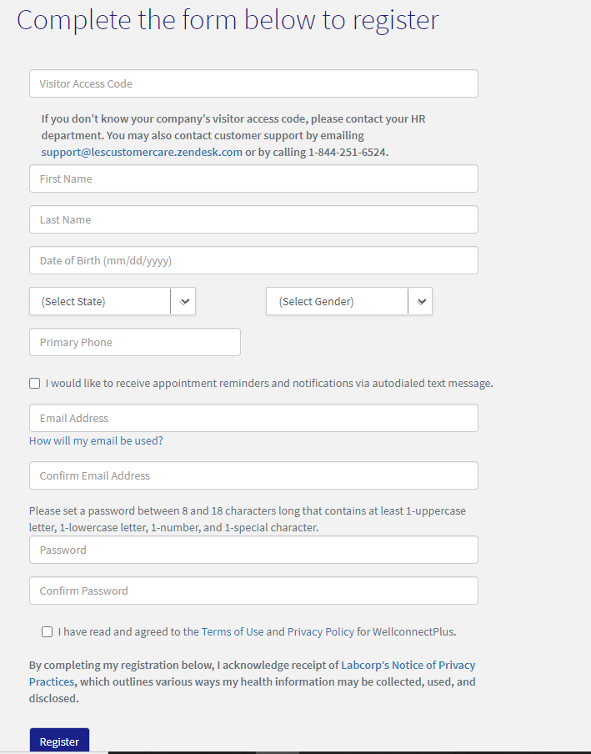

For support, please contact Labcorp Employer Services Customer Care
by email support@lescustomercare.zendesk.com or call 844-251-6524.
The Customer Care Team is available Monday through Friday, 9am - 9pm ET.

